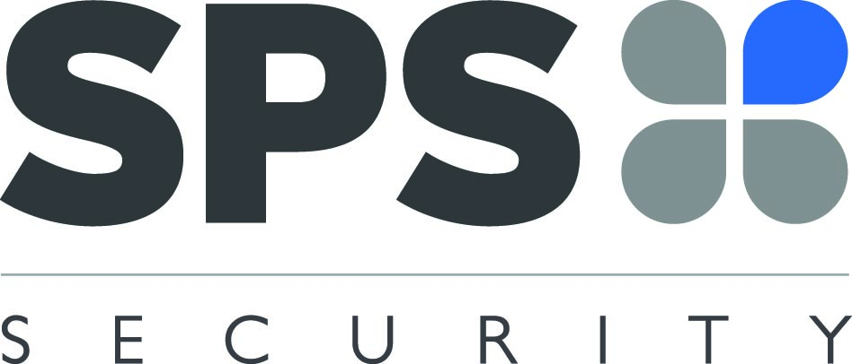

SPS SECURITY LIMITED

THE FUNDING OF APPLICATION FOR YOUR SIA CCTV LICENCE

I ……………………………. confirm that I have instructed SPS Security to apply for my SIA CCTV Licence on my behalf.

SPS Security will provide assistance with the application by linking to my own SIA account and then submitting the application to the SIA following my return of both a complete and accurate application form along with this payment form.

Upon SPS receiving these forms back, a link will be sent to you for you to accept. Only from this point can an application be made.

The current cost of the CCTV licence is £190.00 unless you have an SG / DS already and it has 4 months remaining on it and therefore it will cost £95.00.

In regards to the repayment of the licence cost to SPS Security Ltd, you have two options to select from.

- Full Payment of the licence fee (£190.00) to be paid back to SPS Security in the following month’s payroll. (eg, SPS submit the SIA application in July, the full payment will be taken in August from your wages)

- The Company fund the £190.00 by way of a loan to you, with the loan then reimbursed by you via a deduction of £20.00 per month directly from your wages, spread over 9 months and a final month of £10.00 in the 10th month.

- If the reduced fee is applicable, the Company fund the £95.00 by way of a loan to you, with the loan then reimbursed by you via a deduction of £20.00 per month directly from your wages, spread over 4 months and a final month of £15.00 in the 5th month.

Should you wish to take advantage of option 2, please complete the below section of this form.

With regard to option 2, a number of Officers have indicated that they would like the monthly deductions to commence in advance of the licence renewal applications being submitted to the SIA. If you wish to elect for the early commencement of the monthly deductions, please tick the appropriate selection below.

I wish to take advantage of option 2, with deductions commencing from (please tick below):

- From the first pay day following the submission of my licence renewal application

- From the first pay day following the submission of this form

I agree that should my employment cease with the Company prior to my loan being repaid, I will allow the Company to deduct any unpaid loan amount from my final net wages payment.

Agree Disagree

I agree to repay any outstanding loan balance to the Company, within fourteen days of my employment ceasing, should there be insufficient monies available in my final wages payment to settle any outstanding loan balance.

Agree Disagree

I agree that if I do not conduct any duties following my licence being granted, you agree to pay SPS Security the payments accordingly as directed above or in full as directed by SPS Security Ltd.

Agree Disagree

Please note, if you select ‘Disagree’ to any of the above points, SPS Security will not be able to proceed with the SIA Application

Finally, please complete the below information and return back to SPS Security in the pre-addressed envelope provided.

Name……………………………………………........................

Signature……………………………………………………….

Date……………………….

Email Address that your SIA Account is linked to (This must be written clearly and accurately)

……………………………………………………..…………………………………………….

